Lab 5 – JSON
Both of these problems are to be done with JSON web services (i.e. not XML) and put into HTML pages. These problems deal with client side web services. All I need you to upload are the HTML page for each problem.

Problem 1
Since you did such a good job with the previous zip code application, the client would like the same thing done but on a generic HTML page. Specifically, the page needs the following:
- A text box where the user enters the desired zip code
- A button that the press to get the information
- A list of postal codes that fit the criteria in the following format (look at the screen snapshot below)
  - ZipCode – City
You will use a JSON webservice from geonames.org.
I will be entering the following zip codes:
- 02864
- 9011

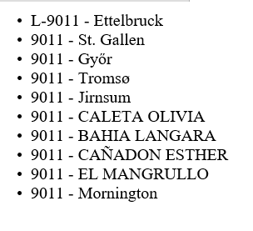
Problem 2
For this problem you are going to need to sign up for an account at the New York Times. The URL is:
https://developer.nytimes.com/signup
Once you sign up and get an apikey, you are going to make a call to get the top stories (V2). The documentation for this is at:
https://developer.nytimes.com/

One you have it, output the results to an HTML page – giving the title, then the byline, then a hyperlink to the actual story. (in html that is <a href=url>link</a> (here url is coming from the webservice and link is just text.
To make it all look good, put it in an unordered list. The output will look something like this:

